Blood Bank Management

-Clone the git project

-Build and run the project

In the swagger you find all these methods

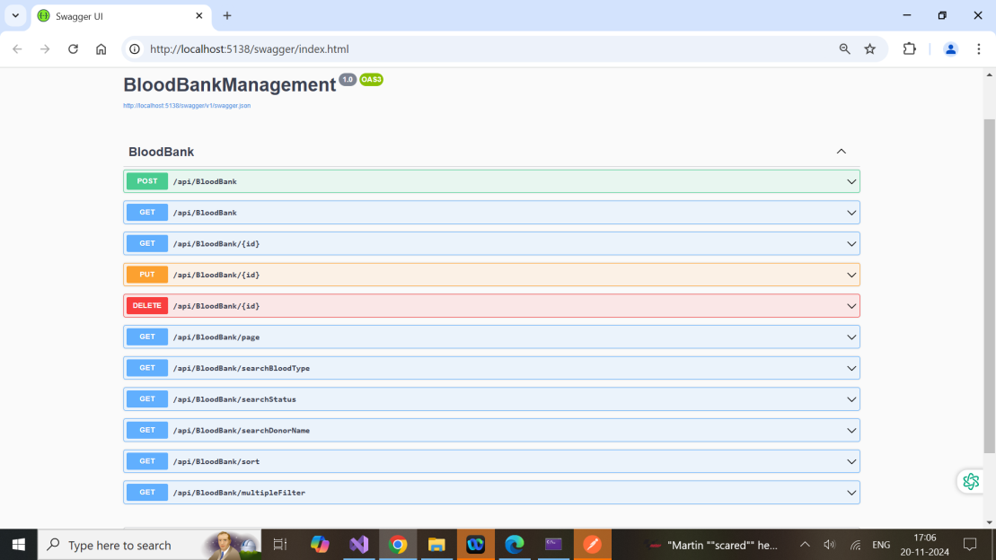

1.Get Method—Retrieve all entries in the blood bank list.

**🡪In Swagger**

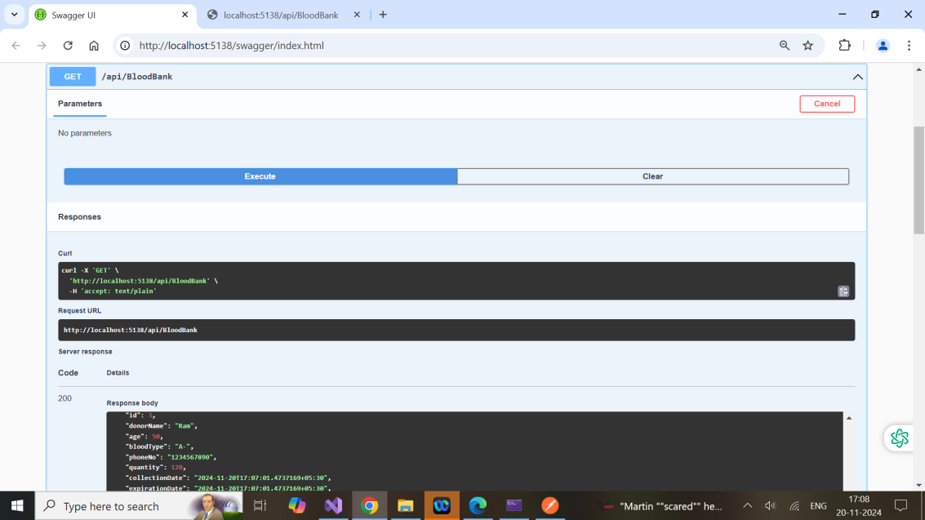

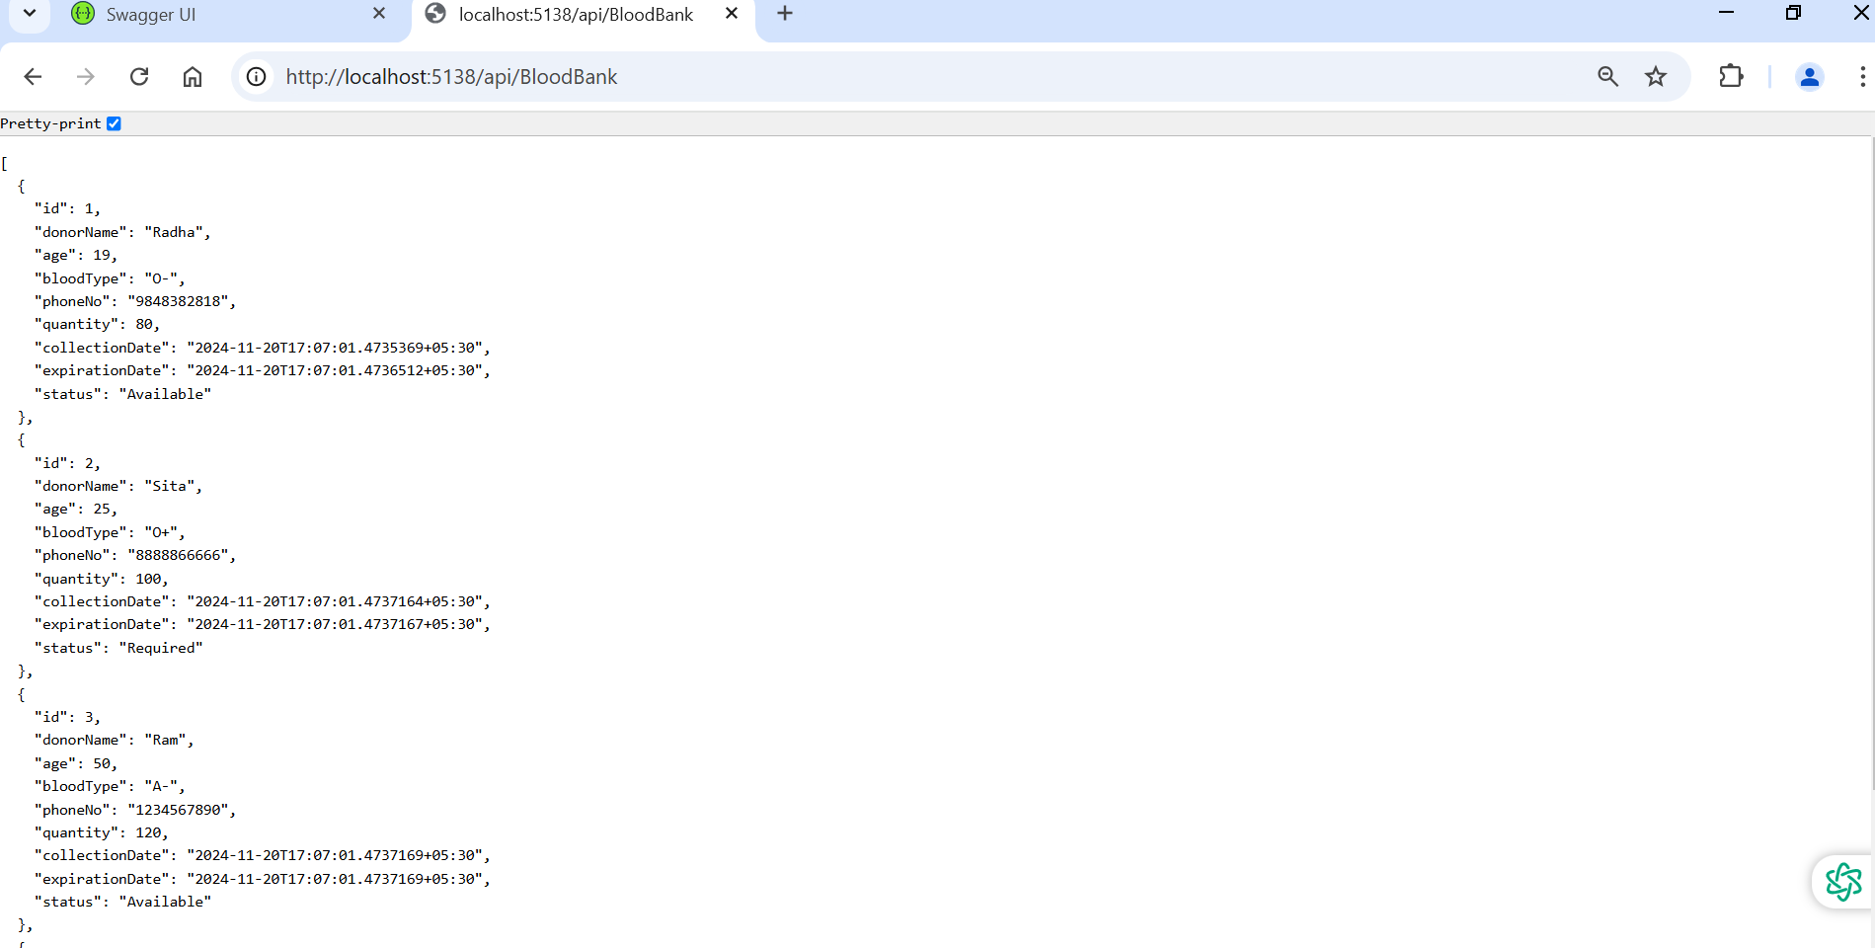

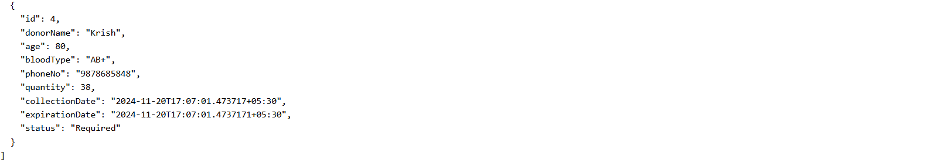

**🡪In Postman**

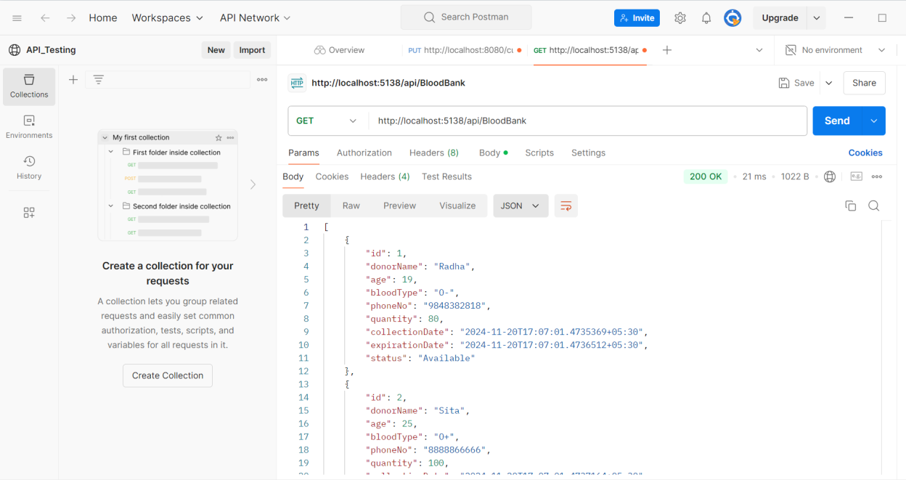

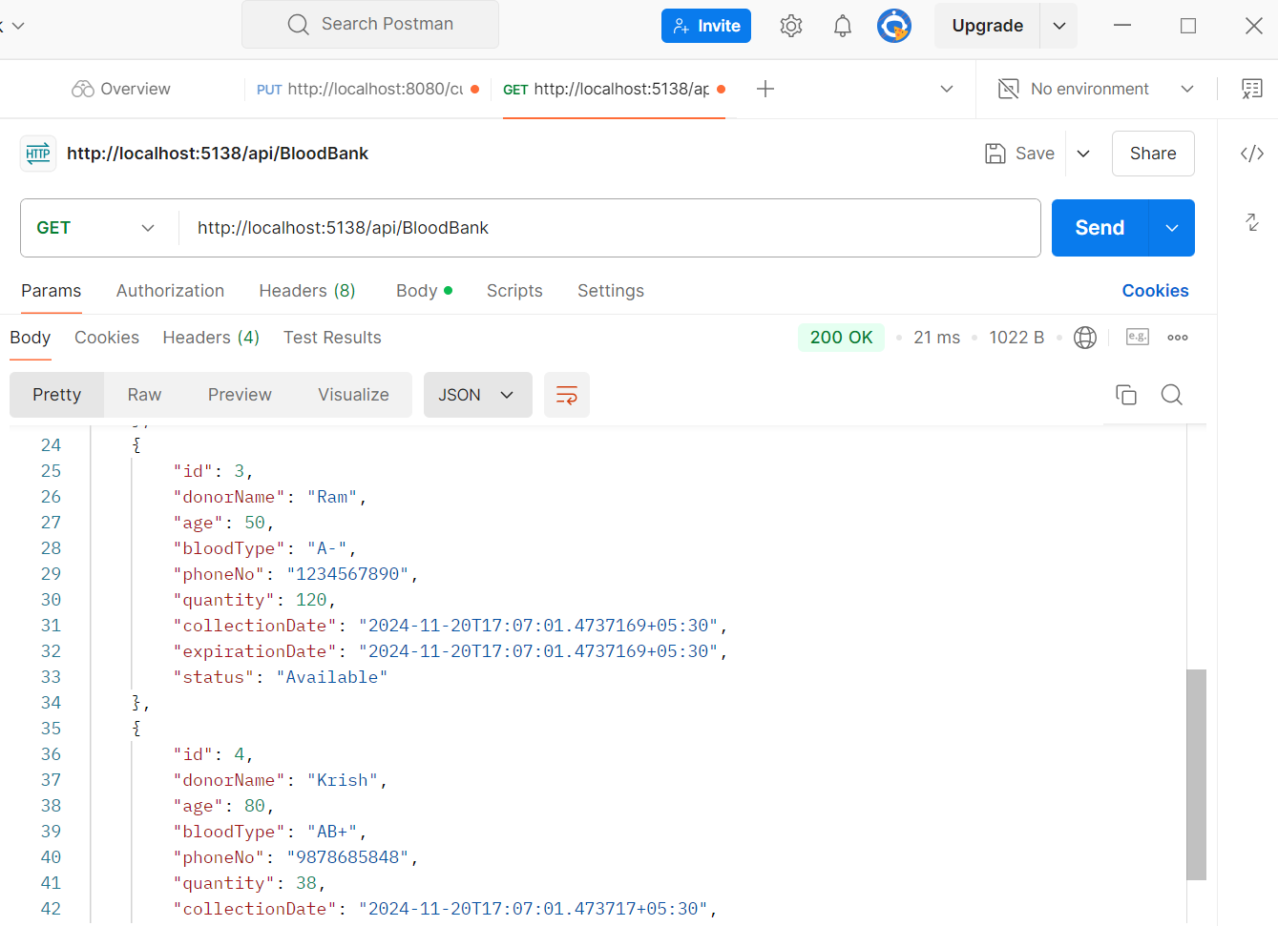

1.Post Method—Add a new entry to the blood bank list.

**🡪In Swagger**

**First we have handled Phone number exception(If the phone number is not 10digits)**

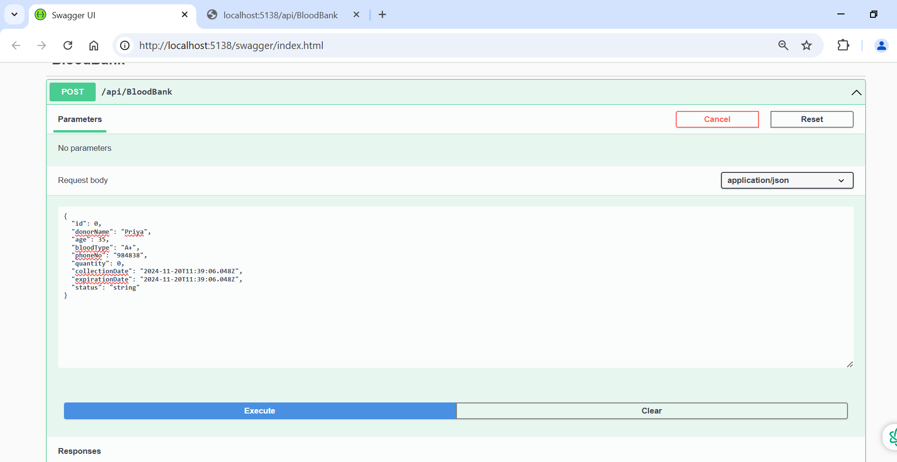

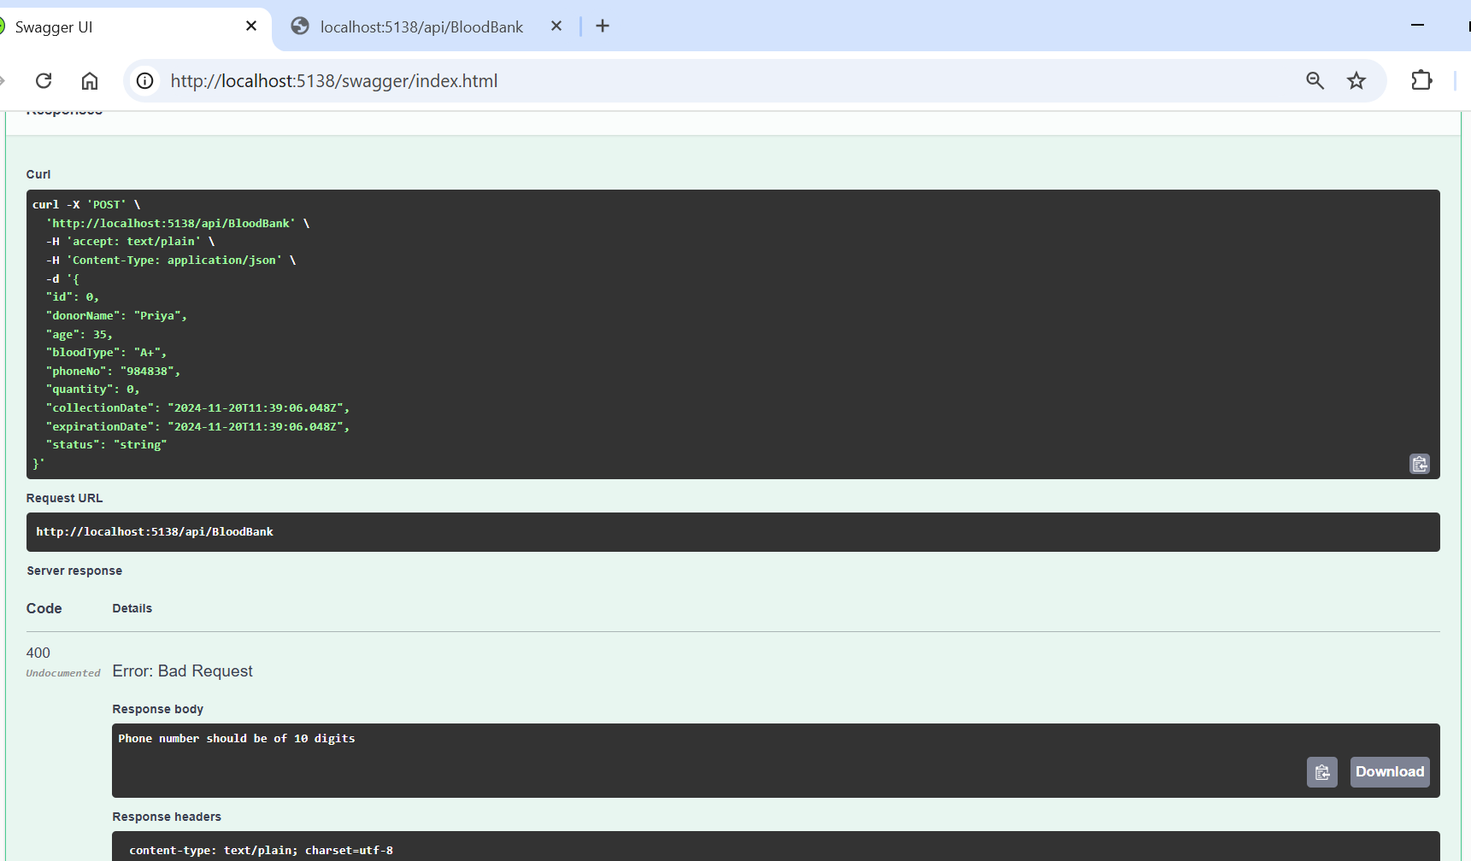

We have handled the situation of age greater than 18 to donate

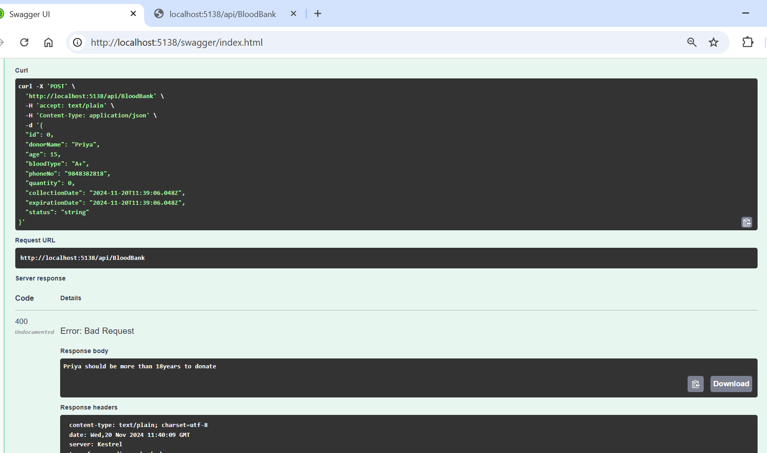

Successful Addition of new entry.

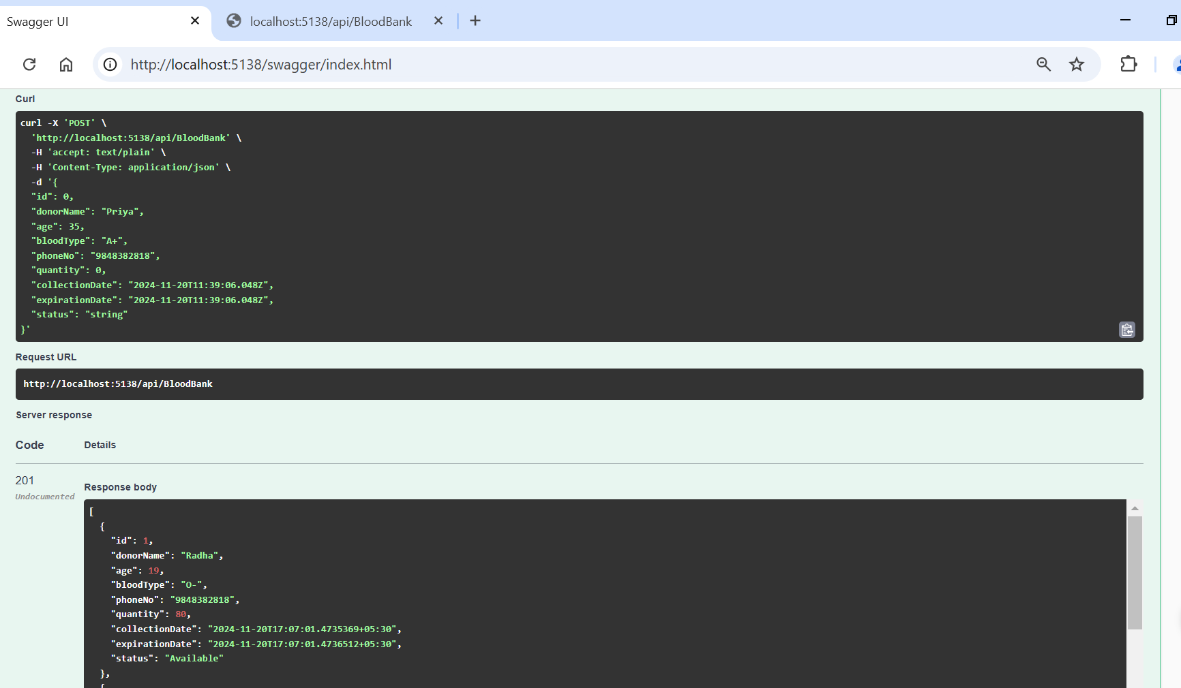

**🡪In Postman**

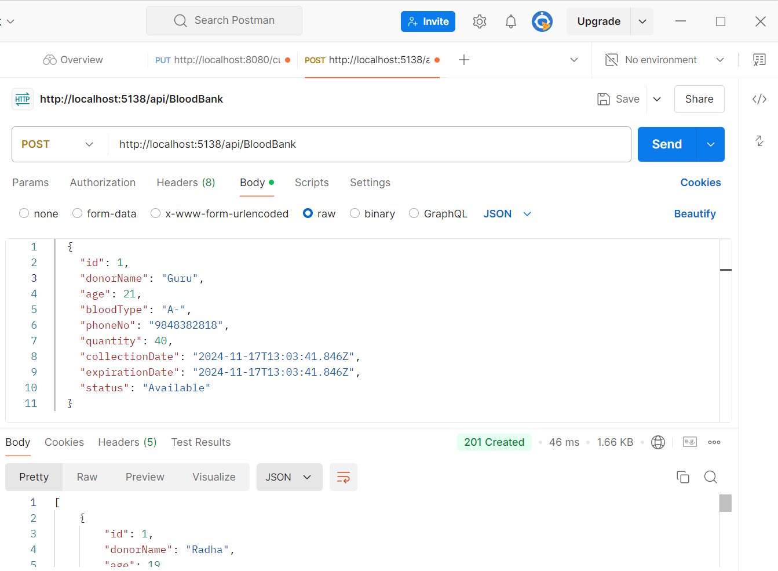

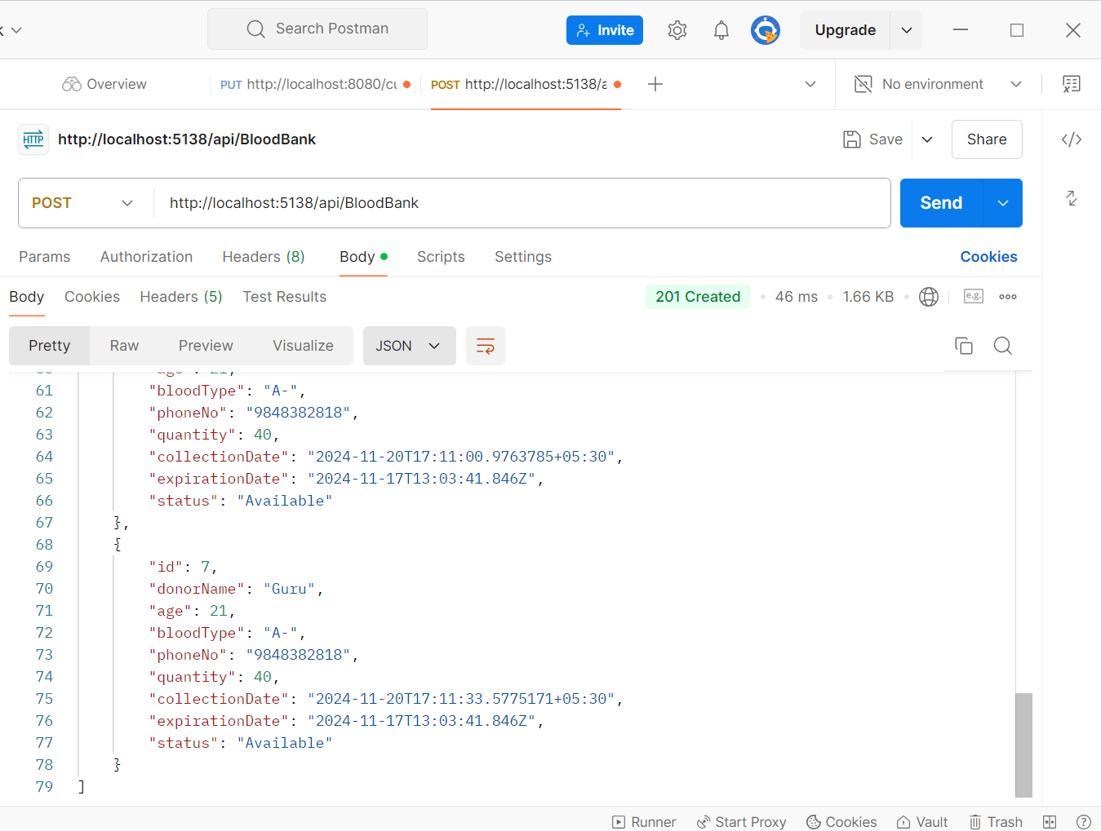

1.Get Method by ID—Retrieve a specific blood entry by its Id..

**🡪In Swagger**

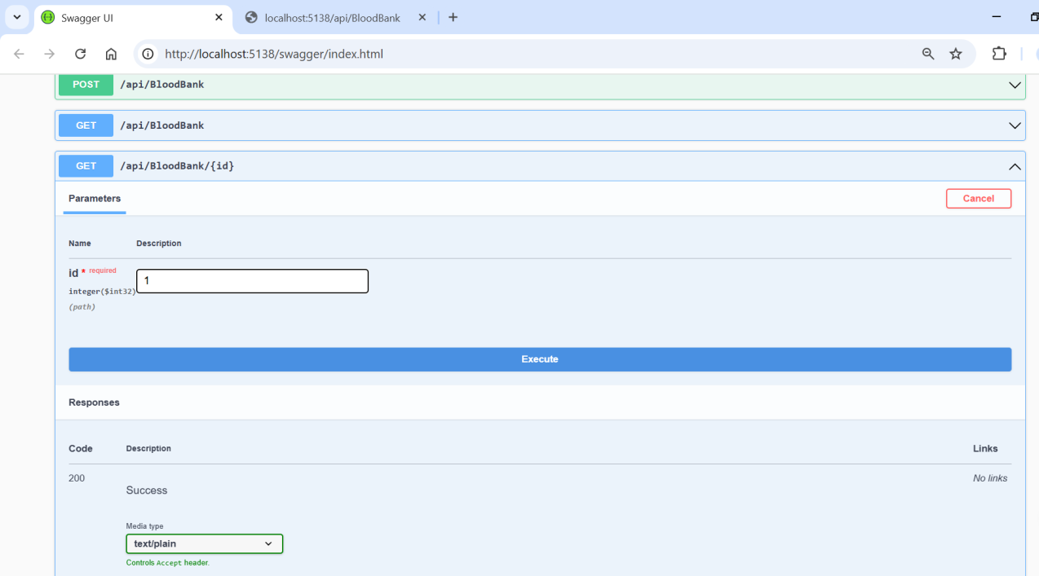

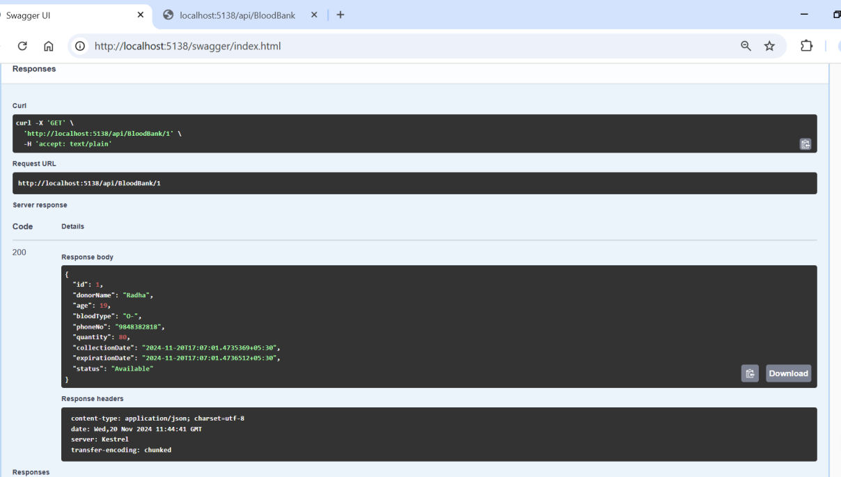

**🡪In Postman**

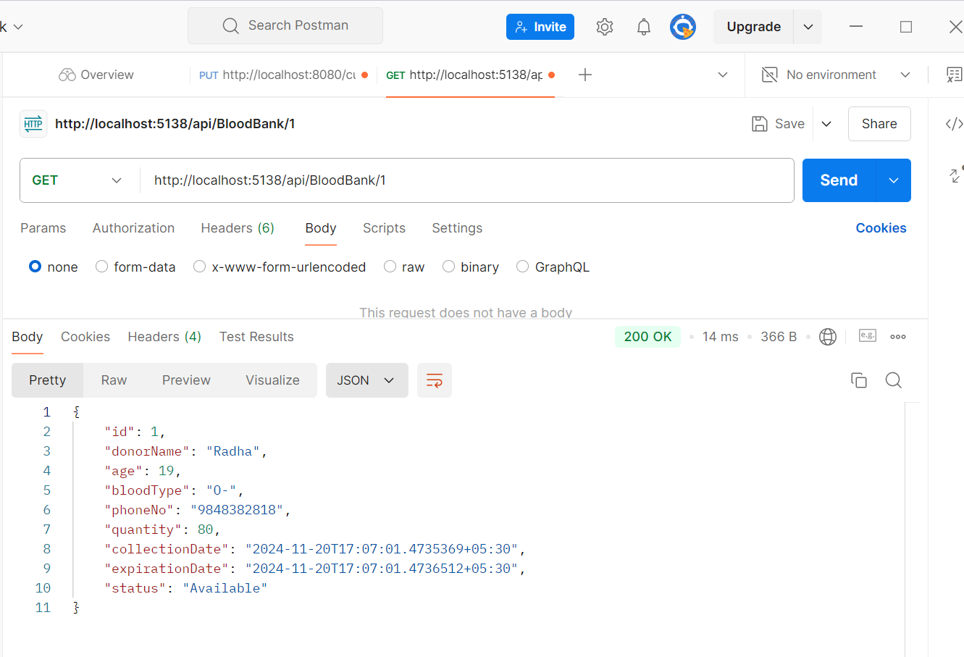

1.Update Method—Update an existing entry

**🡪In Swagger**

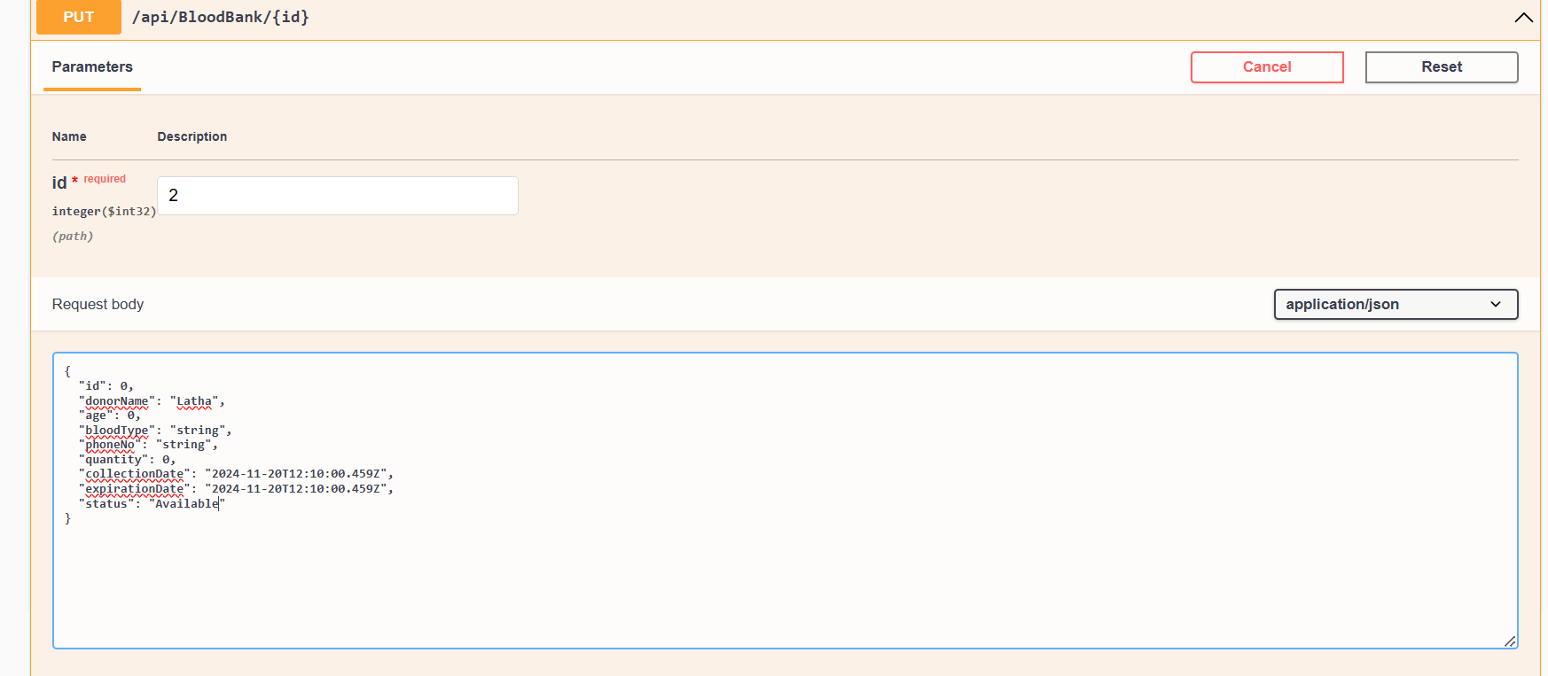

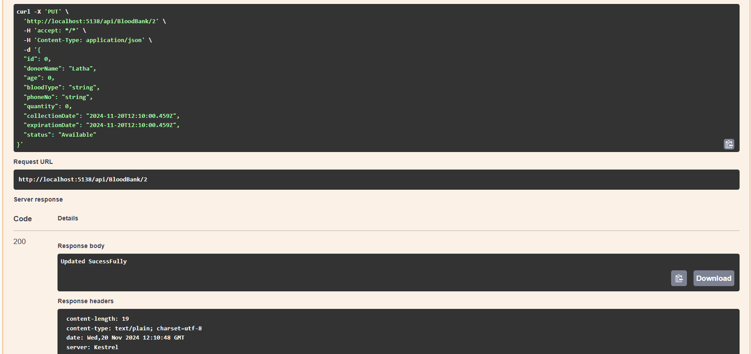

**🡪In Postman**

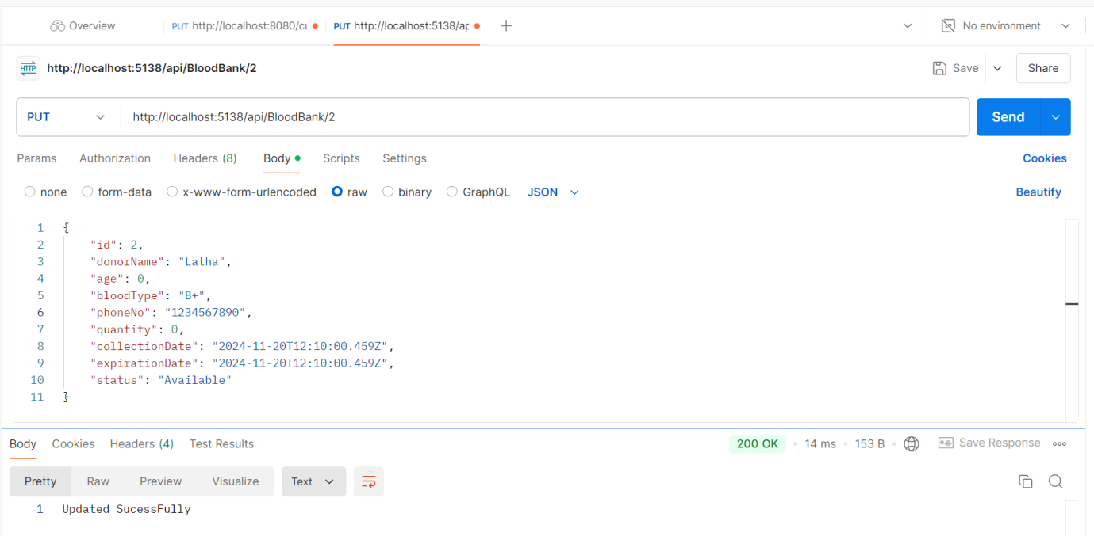

1.Delete Method—Remove an entry from the list based on its Id.

**🡪In Swagger**

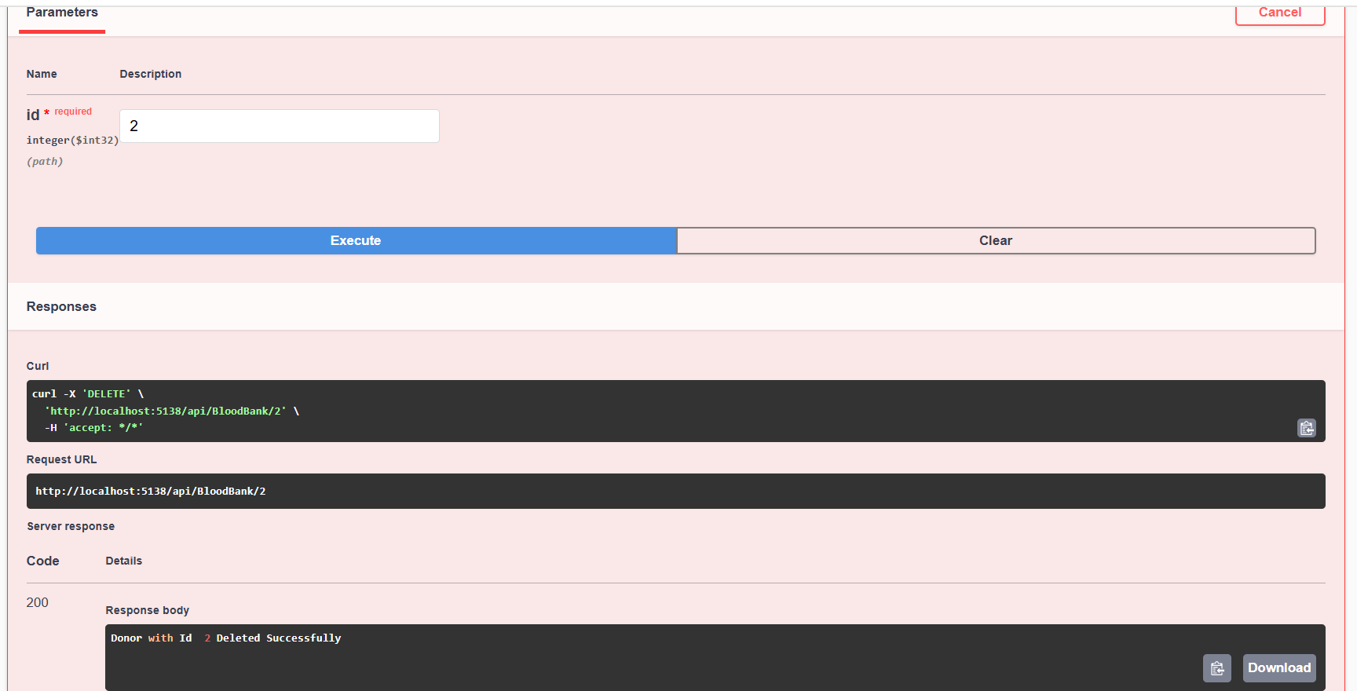

**🡪In Postman**

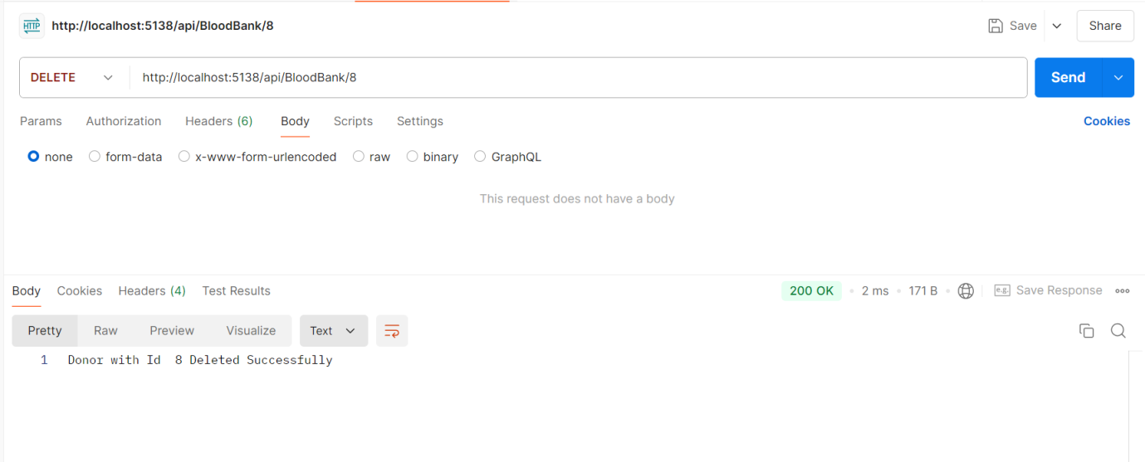

2)Pagination

GET :Retrieve a paginated list of blood bank entries.

**🡪In Swagger**

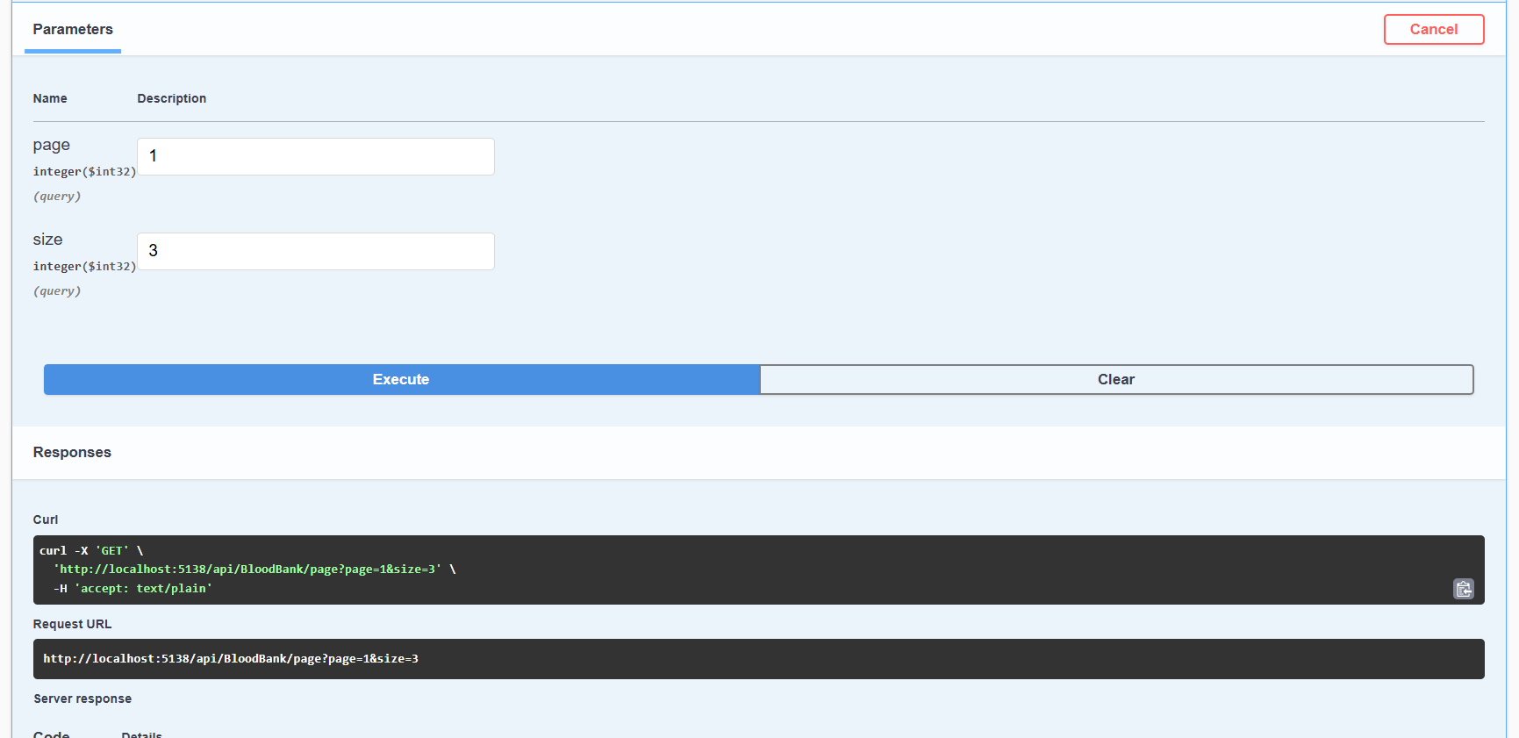

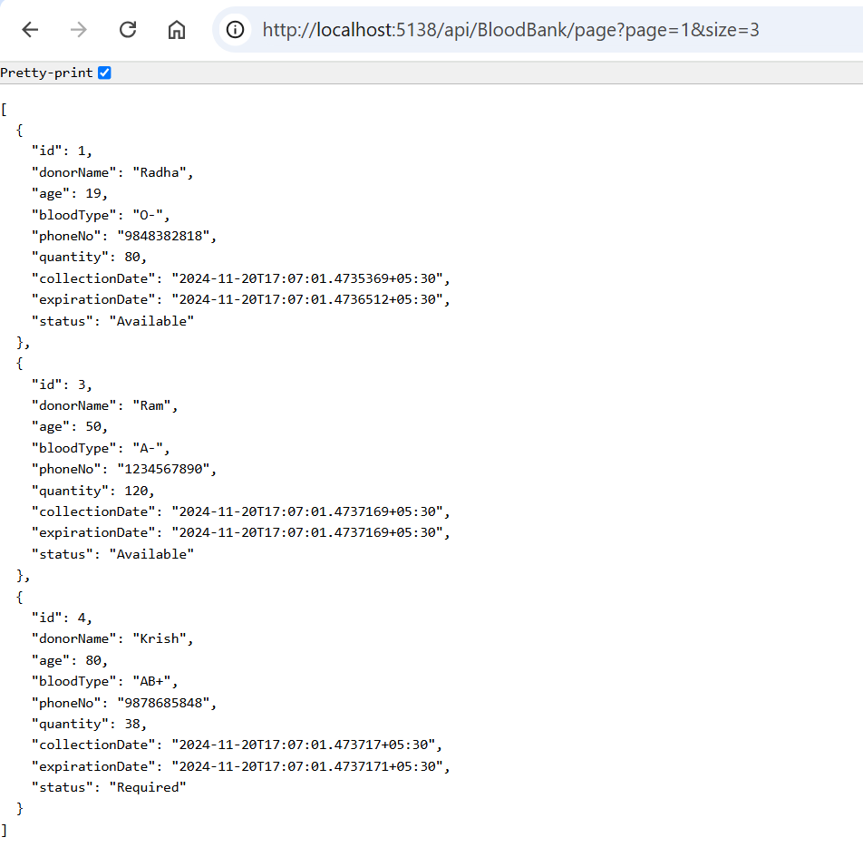

**🡪In Postman**

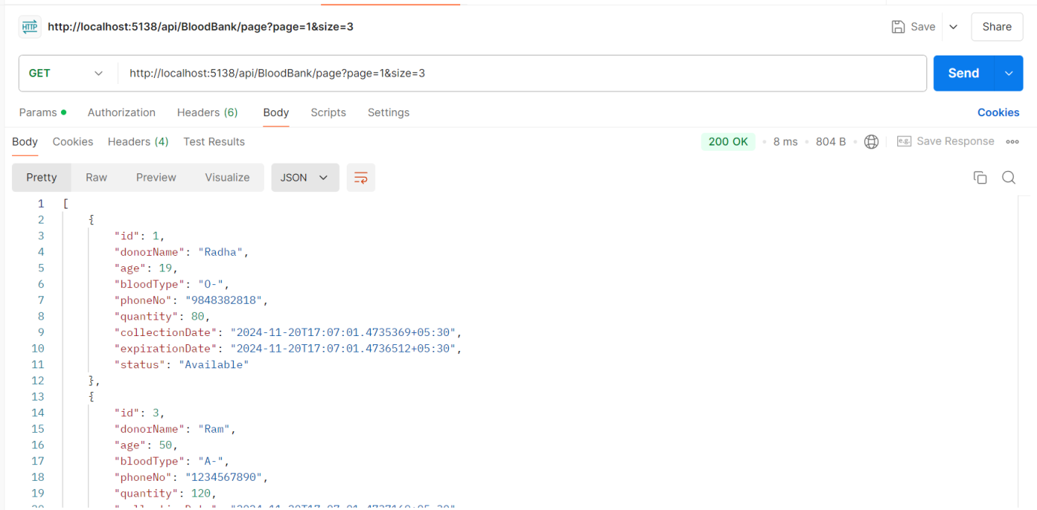

3)Search Functionality

Search for blood bank entries based on blood type.

**🡪In Swagger**

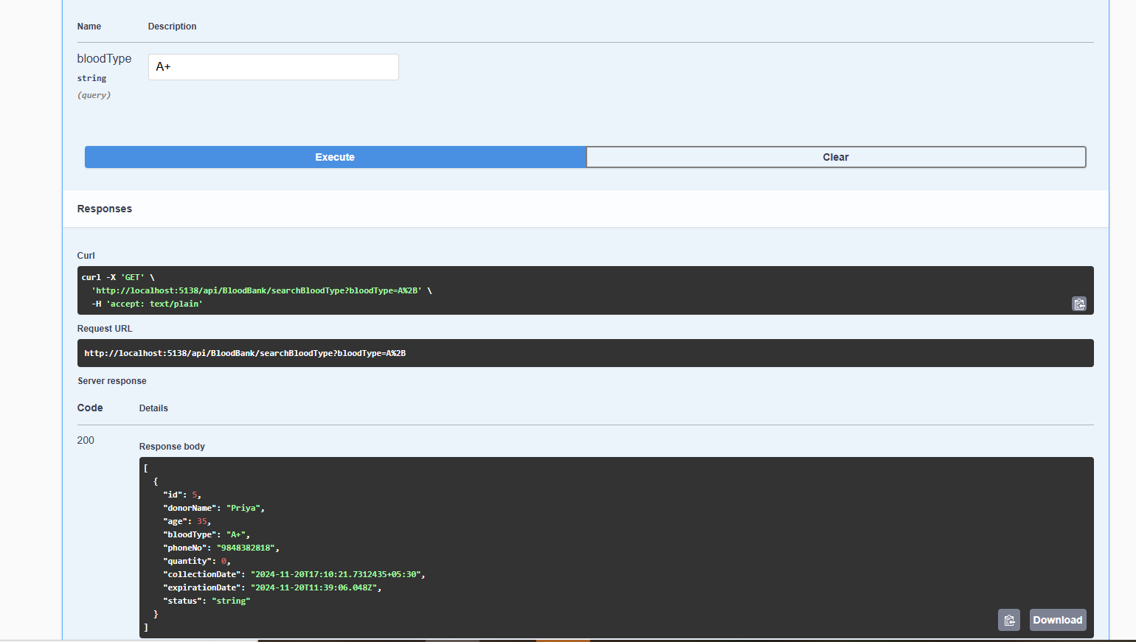

**🡪In Postman**

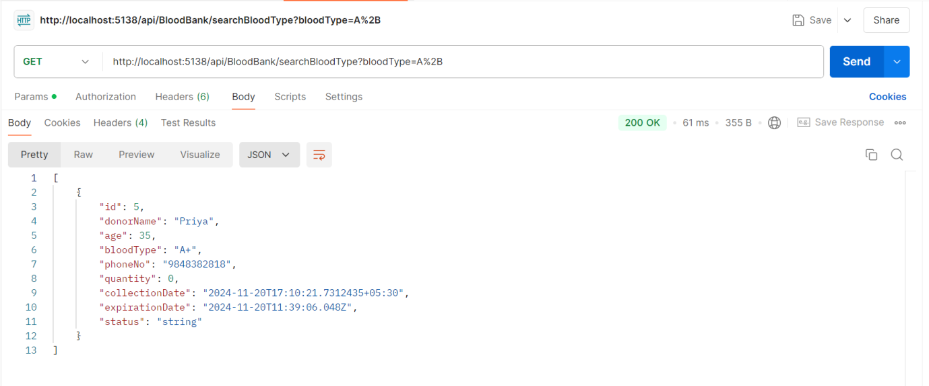

Search for blood bank entries by status (e.g., "Available", "Requested")

**🡪In Swagger**

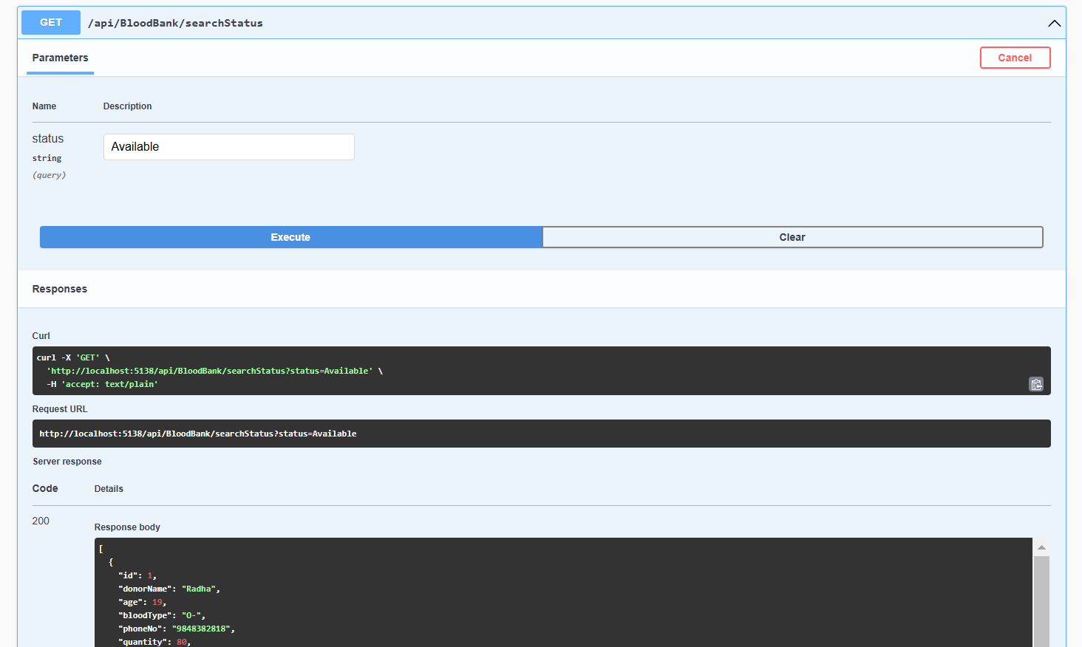

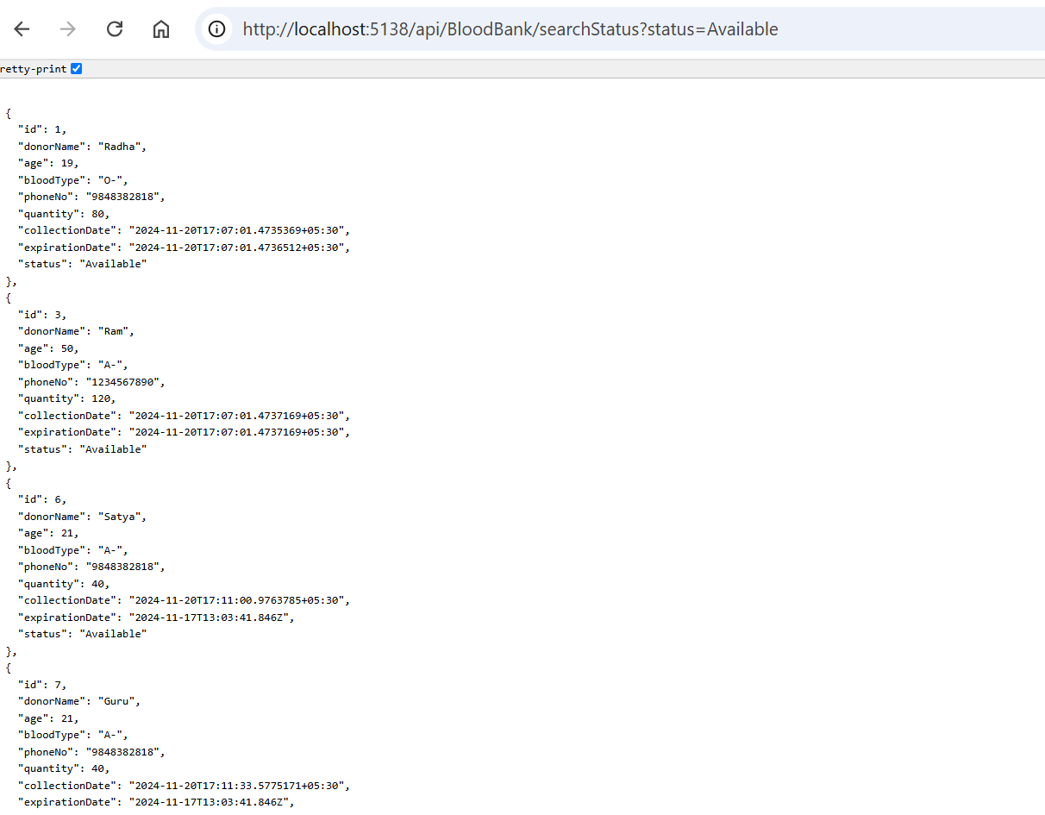

**🡪In Postman**

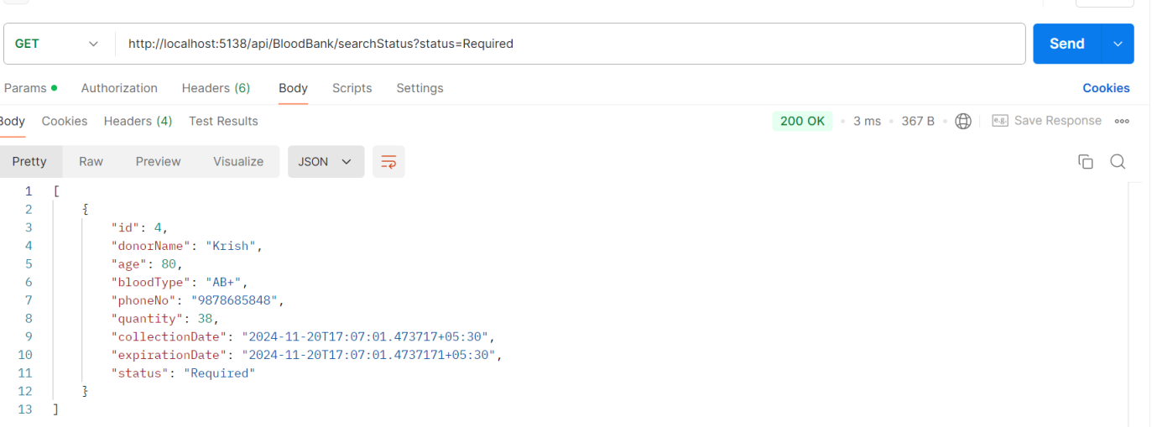

Search for donors by name.

**🡪In Swagger**

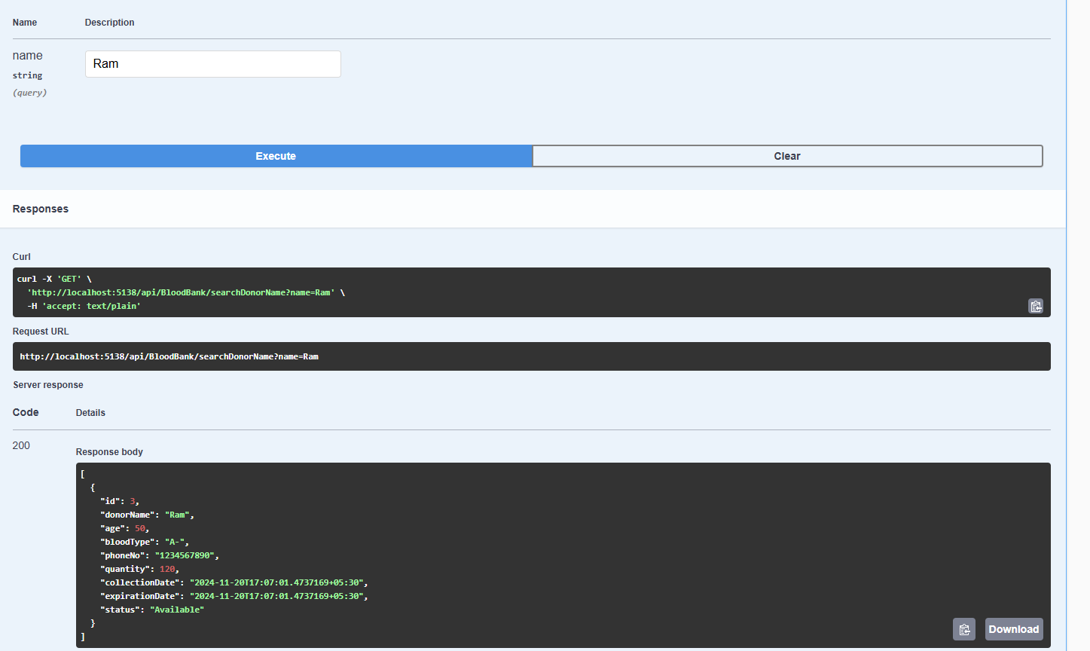

**🡪In Postman**

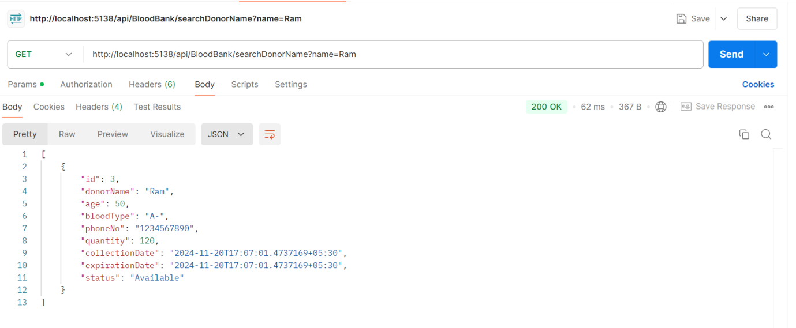

Sorting: Implement sorting capabilities

**🡪In Swagger**

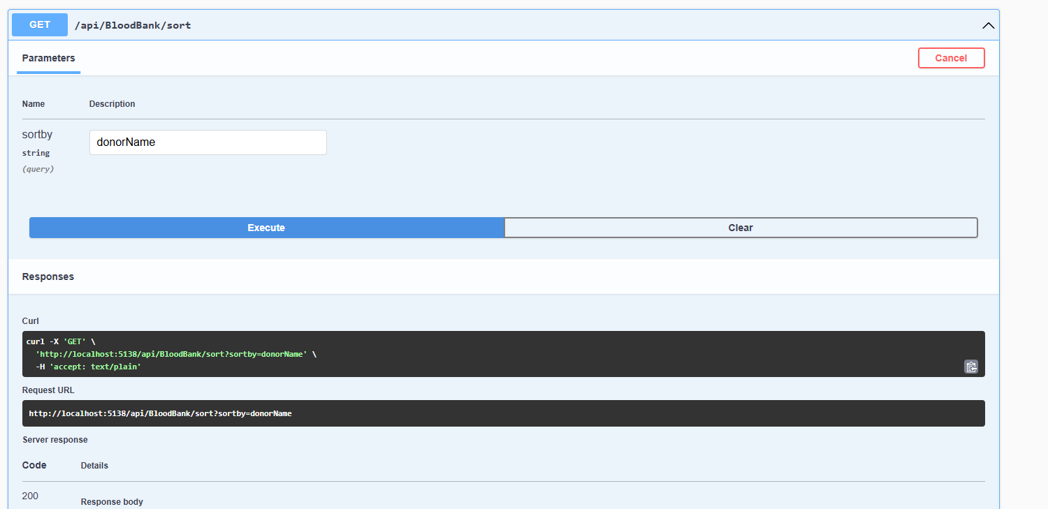

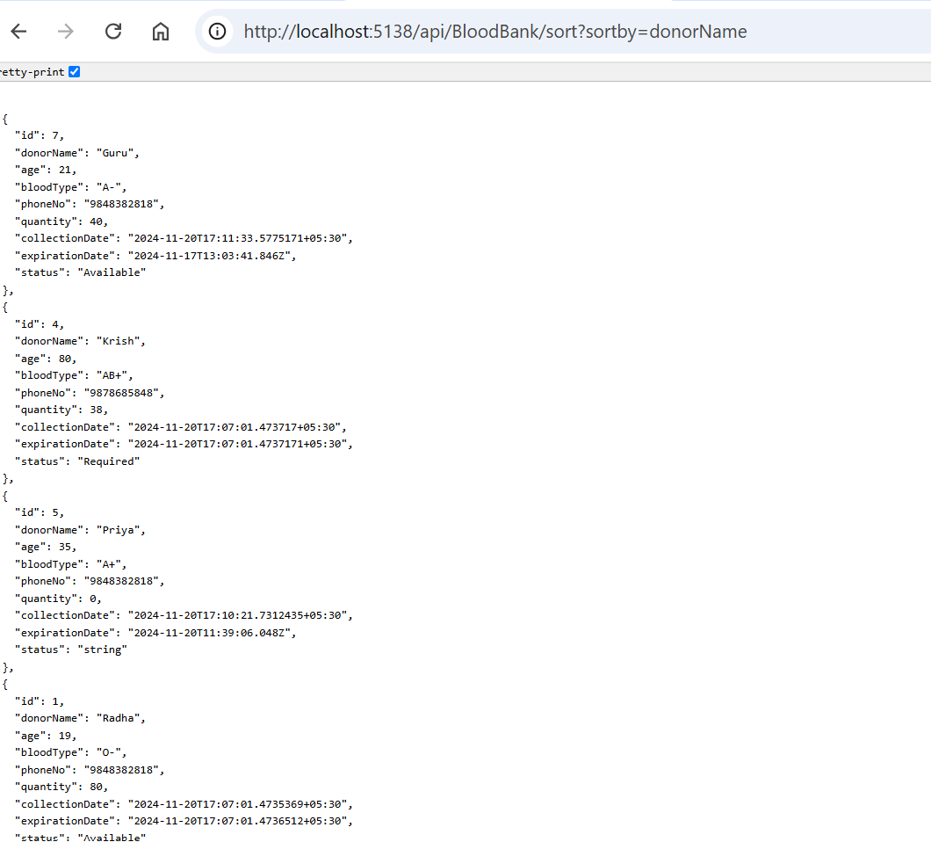

**🡪In Postman**

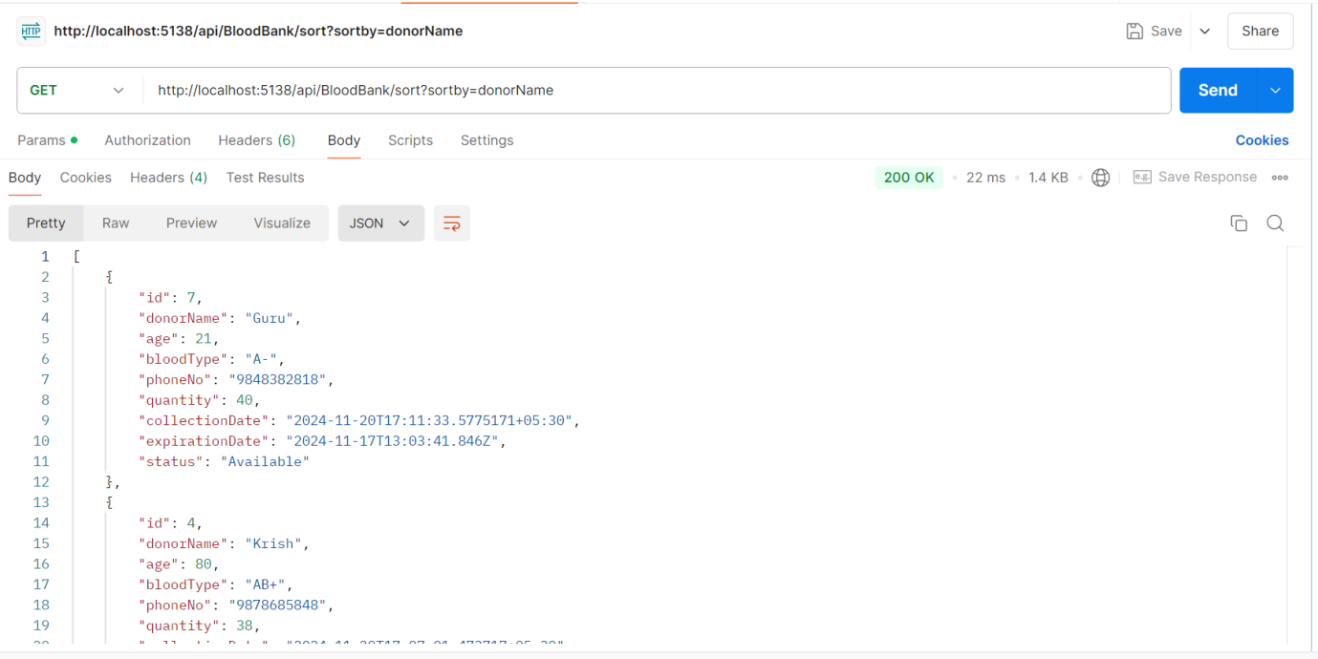

Filtering: Allow multiple search parameters to be used simultaneously

**🡪In Swagger**

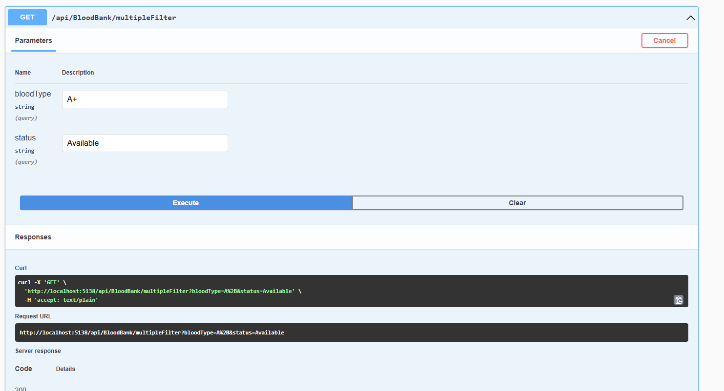

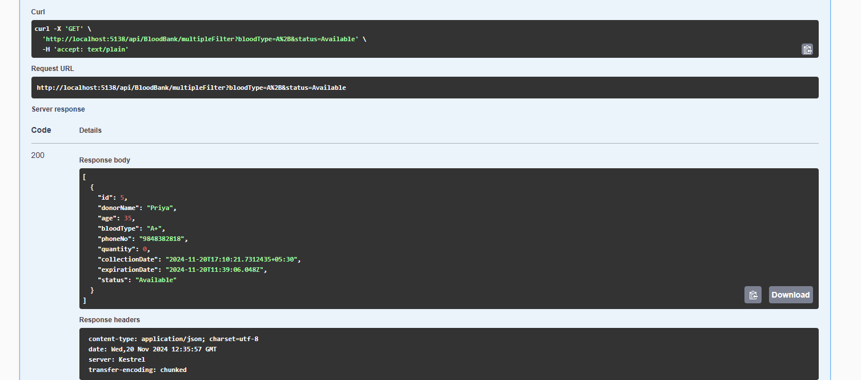

**🡪In Postman**

